Do Social Media Users Interact More with Fast Food or Healthy Food Online?

David D Berberena

Bellevue University

DSC 500 Introduction to Data Science

Nasheb Ismaily

October 29, 2023

Do Social Media Users Interact More with Fast Food or Healthy Food Online?

I’d like to explore the topic of what social media users tend to share their reactions about most readily: food. More specifically, social media users are drawn towards fast food options as well as healthy food options. Now there are many ways to quantify this topic, and throughout my research, I will be sharing what evidence I have gathered through data collection, sifting, and modeling. Let us dive into the world of social media and food.

# Overview: Social Media and Food Awareness

Broaching the topic of social media users being very outspoken about their food preferences through likes, swipes, double-taps, and more begs many questions. Some inquiries are more intricate and telling of human food behavior than others. Many of the questions posed will pertain specifically to the American demographic, as the United States is one of the most culturally diverse countries in the world. There are many factors today that govern humanity’s use of social media in conjunction with the consumption of food, and exploring some of them will lead to an increased understanding of how the social media user processes and responds to food data.

**Analysis and Exploration**

Several potential research questions in direct correlation to the above topic are:

1. Do stereotypes concerning certain foods (fast or healthy) negatively impact social media activity centered around food?
2. Where in the world are online users classified as generally drawn more towards fast food as opposed to healthy food options?
3. Do stressors in social media users’ lives cause an increase in eating healthy or fast food?
4. Are there specific cuisines that are deemed “healthy food” or “fast food” by individuals that could influence their interaction with food-centric material on social media?
5. Do “food influencers” play a role in social media users’ food consumption and interaction based on the type of food (healthy or fast food) they post?
6. Does cyberbullying adversely skew the data that can be derived from social media giants like Facebook, Twitter, Instagram, Tik Tok when it comes to food-related posts and the user’s hesitancy to share their true feelings regarding their food category of choice for fear of fat/body shaming or other forms of online ridicule?
7. What demographic of people do we see interacting with fast food and healthy food respectively via social media?

To begin answering some of these thought-provoking questions with any sense of validity and credibility, various research materials can be accessed. Large databases such as Google Trends can guide in identifying what sections of the world skew healthy or fast food oriented. Looking at a social media website directly can help to see live results of users’ propensity to interact with the foods that interest them most. Research studies that have been conducted on the topic at hand provide relevant information and are typically derived from a credible source.

## Research Findings – Google Trends

Google Trends has allowed me to look further into the second of the outlined questions, as the search engine can show where in the world fast food is more popular amongst residents of the country than healthy food and vice-versa, expressed in different figures. Below are a few visuals to illustrate my findings.

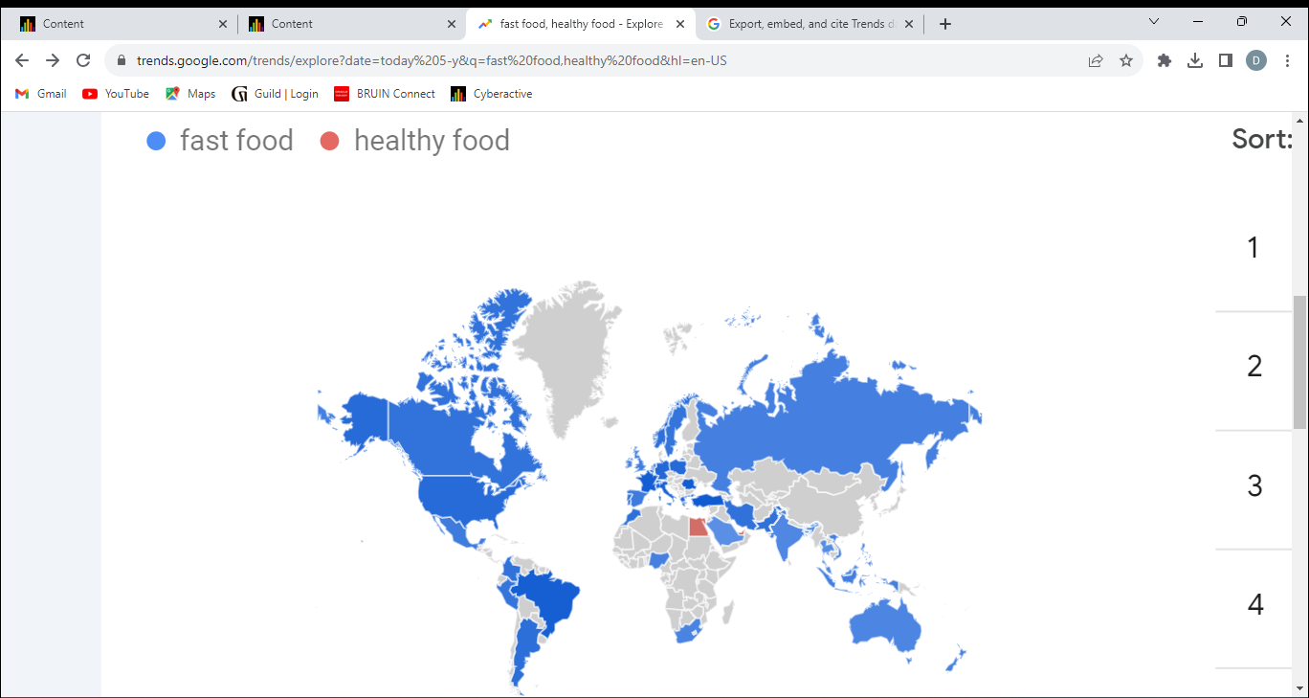

This map provided by Google Trends (n.d.) shows the comparable popularity of “fast food” searches and “healthy food” queries worldwide for the past five years. Only three countries (Egypt, United Arab Emirates, and Singapore) are shown to have a higher percentage of “healthy food” searches, while all of the blue-colored countries have a higher percentage of “fast food” searches.

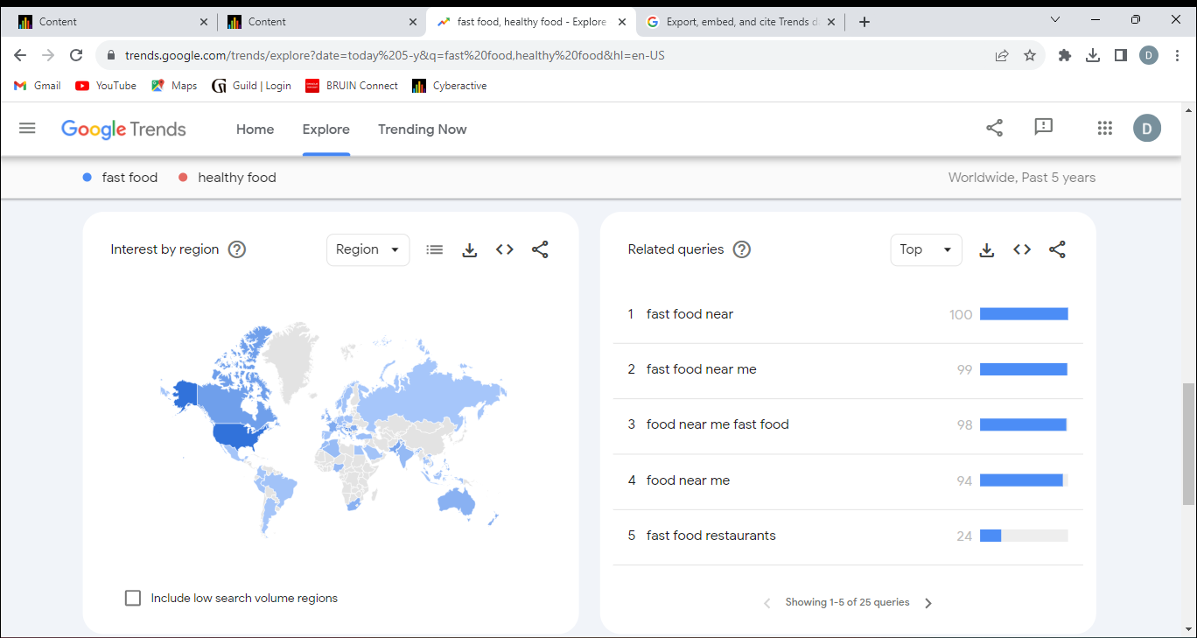

The next visual pictured above shows the most popular “fast food” searches about one another on the right-hand side of the photo. The left side shows the world map with the blue “fast food” search countries in different shades of blue, signifying how popular “fast food” searches are in that location as a fraction of overall popularity between countries.

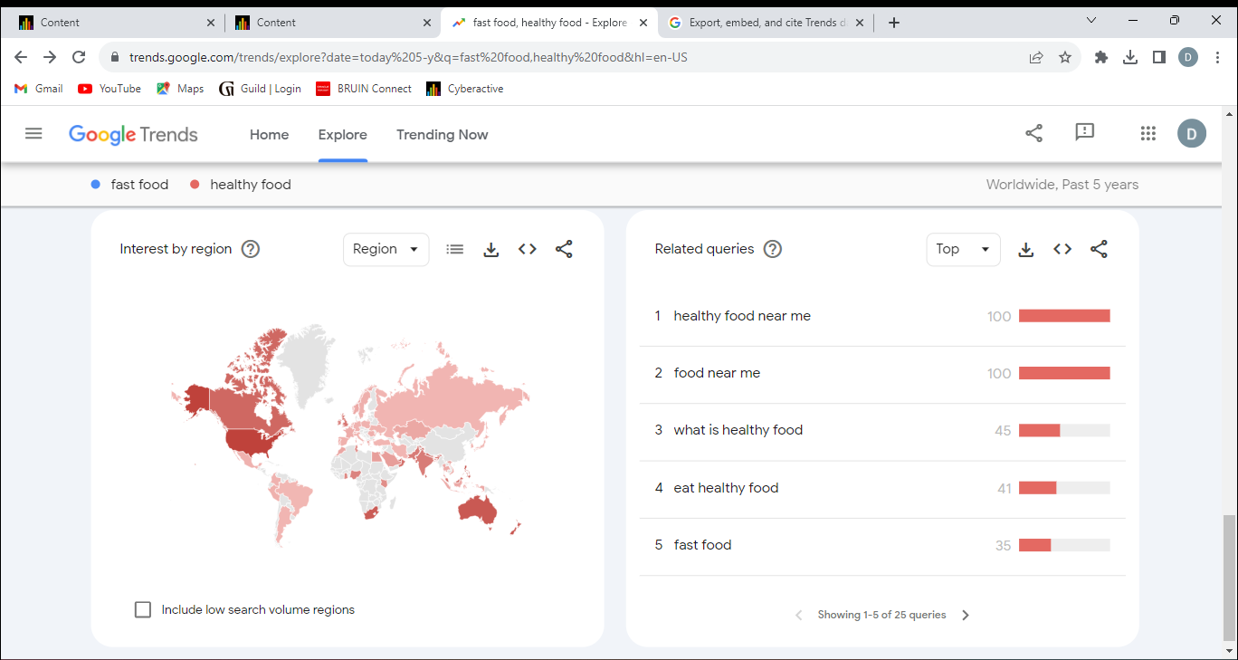

This visual pictured above illustrates the same concepts as the previous map except now with the “healthy food” searches and popularity.

The visuals depicted show that while most of the world is focused on both fast food and healthy food, as evident in their Google search behavior, there is a clear indicator that almost every country that is involved with this data skews towards searches involving fast food much more. Take the United States for a more in-depth example. According to Google Trends (n.d.), the United States shows an interest in fast food much more than in healthy food, with 82% of the combined term searches being solely “fast food” searches. However, both searches are asking the same question by users: where can they obtain those foods near them?

## Research Findings – “Food Influencer” Gordon Ramsay’s Instagram Page, Gordongram

Coinciding with the fifth query listed above, social media users interacting with food-related posts have most likely done so with a post from a “food influencer,” a person(s) renowned for their food-centric content, whether it is because of their experience in the foodservice industry, their relatability to their followers concerning food, their proficiency at making the creation and display of food a hobby, or other means of notoriety. One of the most notable food influencers to date is the famous Gordon Ramsay, known across the world as one of the most decorated and successful chefs today. With his reputation and his ability to capture the hearts and stomachs of his audience, whether on the television screen or in one of his many restaurants, Gordon Ramsay has amassed over 15.5 million followers on his official Instagram page @gordongram (2023). As research material, Ramsay’s Instagram page presents an optimal opportunity to gauge the interactions between a post concerning 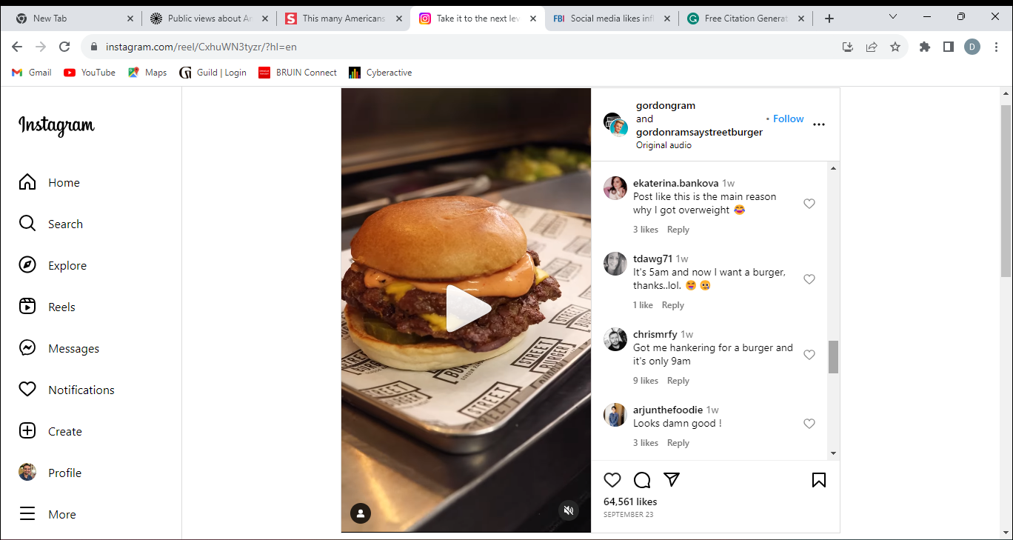fast/comfort food and those of a healthy food post.



Take the above Instagram post for example (users’ profile pictures and usernames have been blacked out for privacy), which was created on September 23, 2023. We can see that the post is a video about the cheeseburger pictured. A burger is synonymous with the phrase “fast food” in modern society, and based on the number of likes shown (over 64,000), many people are not afraid to express their affinity for the burger. The comments on the side of the video show some users’ support for the post and the burger. Looking at Ramsay’s 15.5 million plus fanbase in comparison to the 64,000 plus likes that the post received shows a low follower-interaction ratio, yet that metric is not what needs to be gleaned from the data presented by the post. It is the relationship to the next post concerning a notable healthy 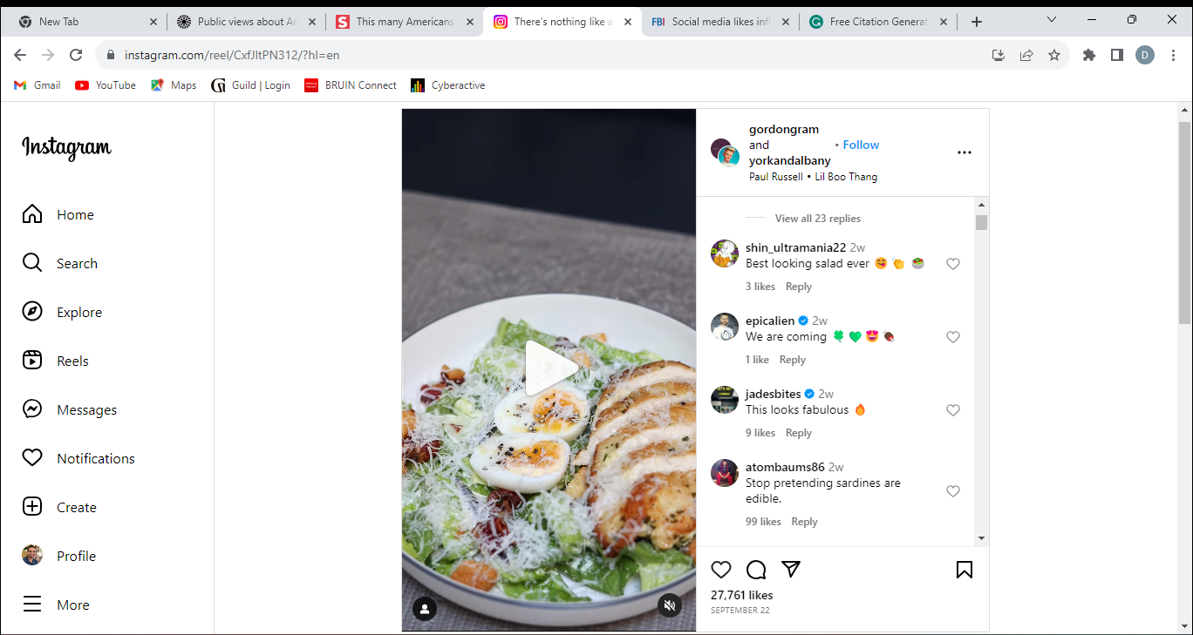food that is much more relevant.



This post was made on September 22, 2023, the day before the previous post. As shown above, the posted food item is a salad, a genre of food that is at the forefront of conversations involving healthy foods. The number of likes on this post is significantly less, amassing an underwhelming 27,000 plus likes and comments to support the presentation of the salad. What we see here is that, solely based on the two posts pictured, Ramsay’s Instagram followers (which are diverse in culture and global location) interacted more with the fast food post than the healthy food post. The number of comments (not pictured above) tied to these posts also proved the same thing.

Gordon Ramsay has a certain style of cooking, and his restaurants across the world reflect that. One such restaurant is Gordon Ramsay Burger, the iteration of Ramsay’s take on the burger elevated. He does not have a restaurant centered around salads, as he is not known for his affinity for salads. Ramsay’s background and current consumer offerings have built his credibility as a food influencer and have indirectly affected the interactions of his Instagram followers regarding his food posts. However, just because social media users interact more with fast/comfort food than with healthy food (at least in this example as this scenario does not define the full scope of the expected answer), the question as to why that is still looms overhead. Research studies can provide insight here.

**Research Findings – Studies**

Collecting data that outlines potential causes of specific social media user interaction patterns regarding fast food and healthy food options delves into societal issues that individuals struggle with regularly. One such study conducted by Aston University's College of Health and Life Sciences showed that individuals who viewed healthy food posts with a higher level of engagement (likes in this scenario) than those who did not ate more healthy food options available under a controlled environment (Smolokoff, 2021). The results here suggest that social media users who view posts with a high (this is subjective to each user) amount of likes and comments believe that it is normal and socially accepted to eat the foods featured in these highly engaging posts. Increased exposure to such posts also could lead to increased healthy food consumption according to the study results, meaning the more a social media user sees fast/comfort food or healthy food, the likelihood of a user consuming food within that featured category rises.

Another area of study that needs to be taken into account is a user’s perception of fast food and healthy food. What does it mean to eat healthy, and why should a user do so? What foods are considered healthy and what qualities do those foods have that designate them as “healthy?” How much food can be consumed in one sitting for that meal to be considered “healthy?” Perception relating to food is one of the major driving forces for food service businesses, and social media accentuates the reputation food has within society. A 2016 survey conducted by the Pew Research Center highlighted Americans’ perceptions of eating healthy and how they view current eating habits comparable to twenty years prior (2016). The results showed that Americans are paying more attention to healthy foods than back in the day, yet are not capitalizing on their heightened awareness and are eating less healthily than two decades ago. Americans also have stated that the food we are currently consuming is not healthy enough and that we are eating too much food to be considered healthy. 58 percent of Americans surveyed said that they are aware that they need to be eating healthier, yet are not doing so. We’ve seen a potential reason for social media users to eat food that they have seen as popular amongst other users via engagement metrics, but why would they not eat a certain way if they know they ought to be for the longevity of their life?

A study conducted by Sensodyne involving American eating habits during their COVID-19 isolation period yielded intriguing results in response to the aforementioned question of stressors affecting the consumption of healthy and fast foods. With Americans stuck indoors, of the 2,000 surveyed, 37 percent shared that they ate comfort food every day, while another 38 percent ate comfort food every other day (D., n.d.) The study goes on to list the comfort foods that were enjoyed by the survey respondents while listing favorite memories that the individuals shared concerning their families and food. Of the top ten memories stated, only two could be equated to involving healthy food options (enjoying watermelon with siblings and Sunday roasts with potatoes, carrots, and onions). The stressor magnified by this study was self-isolation during the pandemic. The direct effect of that isolation according to the study was the increase in comfort food consumption. Other stressors not mentioned in the research material could be the possibility of cyberbullying, public ridicule, medical conditions such as anorexia bulimia, and other eating disorders, severe anxiety, etc. How social media users can cope with these stressors can determine how they move forward with their online interactions with either fast/comfort food or healthy food.

**Assumptions**

Now as we are looking deeper into the social media user interaction pool regarding healthy food options and fast food suggestions, there are assumptions that can be made that may or not hold true. The interaction these users have with these posts suggests that they have some form of interest in the foods they are liking, commenting on, and/or sharing. What a social media user’s specific interest is would be hard to decipher through the viewing of the interaction alone, as they could be interested in buying the food, eating the food, promoting the food, cooking the food, etc. Interaction in general assumes positive interest, yet there are also forms of interaction on social media that help users express a negative opinion concerning the post. Facebook in particular has done well to allow users to interact with posts using emojis, some of them being faces or emoticons of positivity (hearts, happy faces, etc.) and some conveying a dislike for the post (broken heart, angry/sad faces, etc.).

Another assumption is that many of these social media users are telling the truth about how they really perceive the food they interact with online. As mentioned above in one of the posed inquiries, cyberbullying is a real issue in today’s society. Any online interactions are scrutinized by some individuals looking to make users feel bad or uncomfortable with their true feelings on a post. Say for example, a rather large individual likes and comments positively on a post involving a large quantity of fast food and other users look at their profile and see that the individual is overweight. These users may easily begin replying with disparaging body-shaming comments, making the individual uncomfortable to comment again on fast food posts in the future. To make up for this unwarranted harassment, the individual may express interest in posts involving healthy food options and positively interact with these posts to avoid more cyberbullying when they truly care about the fast food options that they have now been made uncomfortable liking, commenting, or sharing.

It is noted that these assumptions and more are present, yet taking them into account by viewing the data may have varying degrees of success.

**Ethical Concerns**

Arriving at the topic of data ethics most often calls the question of privacy to the forefront of the conversation. If sensitive data that divulges a person’s willingness to interact with certain food related posts on social media were to be compromised, the social media users involved in the dataset could be adversely affected. Nobody wishes to have their private thoughts be placed into the open, whether it be online or in person. As social media allows individuals to share their preferences so readily with a sense of anonymity, having that privacy ripped from social media users may make them feel unmasked in a way, as other users would now be privy to their true thoughts. Regarding the main topic and the above visuals, if I had not taken the liberty to black out the usernames of those who commented on Gordon Ramsey’s posts, other users could see who commented what and potentially respond positively or negatively to them after reviewing the data analysis within this expository piece. This loss of privacy could lead to an increase in cyberbullying, especially if users are being targeted by what they comment on a post, like the first comment listed next to Gordon Ramsey’s burger post: “Post like this is the main reason why I got overweight (laughing emoji).” Privacy is an important aspect and ethical concern of any data-driven research study; even more so when it could potentially lead to negative societal issues.

Another ethical concern behind the collection of data to glean an understanding of how social media users interact with healthy or comfort foods is the lack of transparency in how that data is collected. Social media users have a right to know what data is being collected on them, and whether that data is anonymized or not. Anyone reading this paper can tell that the data collected here had some basis in user-specific collection. Usernames were seen, and while they were not used in any way to influence the perspective the data unveils, social media users have a right to know what research studies do to gather their data and what they do to anonymize their data for the public not to discriminate or perpetuate biases. As a news reporter would say, the public has a right to know!

**Challenges/Opportunities**

While gathering the data needed to present a proper analysis of the topic at hand, challenges have cropped up that bring the true breadth of the topic front and center. Looking at some of the Google Trends results, specifically the visualization of the popularity of “fast food” searches versus “healthy food” searches, many more questions than answers arise from the data that could affect the validity of the interaction of these social media users with the aforementioned food posts. Do the countries that have a higher ratio of healthy food searches to fast food searches have more access to these healthy food options? Can the majority of social media users within the countries that glorify fast food searches afford more healthy food options to garner more interest in these options as opposed to interacting with fast food options by default? How can the gathering of data ensure that the population of social media users is interacting with the respective posts truthfully and without coercion or improper stimulation by outside forces? What other elements of a fast food post or healthy food post impact the user’s affinity for interaction? These challenges are worth digging deeper into further down the research line to qualm any noise in the data to present the maximum intended amount of strong signal data.

The opportunities created by the study are thought-provoking just as much as the challenges that can be overcome. The ability to increase positive interaction from social media users by learning to master the elements of a fast food or healthy food post that drive users to participate on an altruistic level is very desirable to strive for. The opportunity to understand how and, more importantly, why social media users interact more with certain healthy or fast food posts could branch into the psychology field by potentially helping individuals with eating disorders or other food-related illnesses rewire themselves so that they may view and interact with healthy food (or food in general) as a safe and stimulating option to better one’s health. I personally see the challenges and opportunities this study presents as one and the same, as both prompt the data or the why. While the results are fascinating, the truly life-changing impact of this study may indeed lie in the questions afterward.

### Conclusion

The next order of business will be to peruse data about the demographic of social media users interacting with fast food and healthy food online. We now know that there are plenty of people interested in searching for both categories, as the Google Trends data as well as Instagram data confirm that. Understanding has been found in social acceptance led by high social media engagement, potential stressors, and user perception involving both categories of food. We need to eventually identify these people to know exactly the kind of users who like that Salt Bae video on Instagram, who frequent the Heart Attack Grill Twitter page, or even who comment their support on a Facebook post outlining alternative healthy ways to make unhealthy sweets. Understanding these social media users on a more data-driven level will help us see how they currently interact with these foods and posts online and potentially guide us in predicting how these users will interact with future, unpublished foodie media.

References

Google Trends (n.d.). "Fast Food, Healthy Food". Retrieved September 16, 2023, from <https://trends.google.com/trends/explore?date=today%205-y&q=fast%20food,healthy%20food&hl=en-US>

Instagram from Meta (2023). Gordongram. Instagram. Retrieved October 7, 2023, from <https://www.instagram.com/p/CxfJltPN312/?hl=en>

Smolokoff, A. (2021, October 6). Social media impacts consumer eating decisions. Food & Beverage Insider. Retrieved October 7, 2023, from [https://www.foodbeverageinsider.com/market-trends-analysis/social-media-impacts-consumer-eating-decisions#](https://www.foodbeverageinsider.com/market-trends-analysis/social-media-impacts-consumer-eating-decisions)

Pew Research Center (2016, December 1). Public views about Americans’ eating habits. Retrieved October 7, 2023, from <https://www.pewresearch.org/science/2016/12/01/public-views-about-americans-eating-habits/>

D. (n.d.). This many Americans are eating more comfort food than ever before to cope with isolation. Retrieved October 7, 2023, from <https://swnsdigital.com/us/2020/07/this-many-americans-are-eating-more-comfort-food-than-ever-before-to-cope-with-isolation/?amp=1>